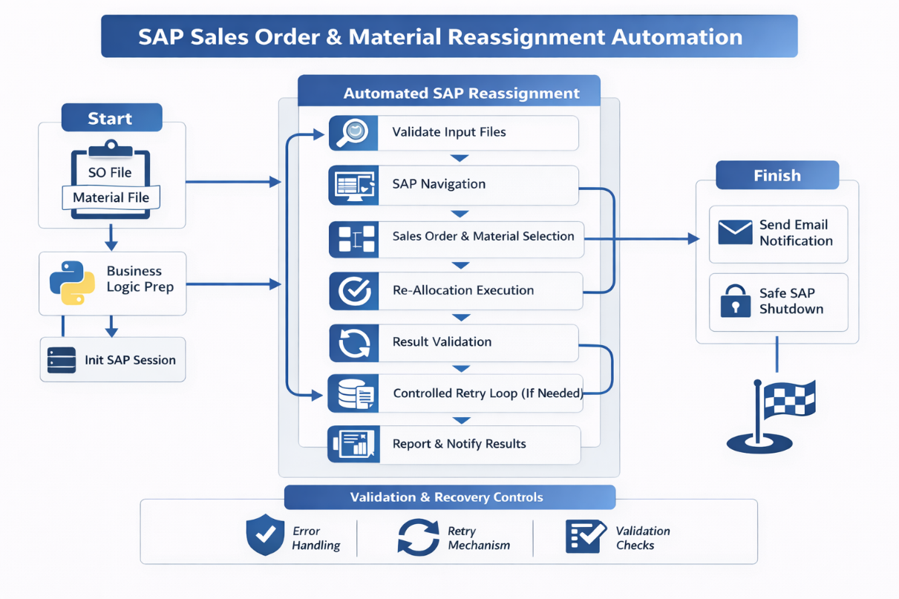

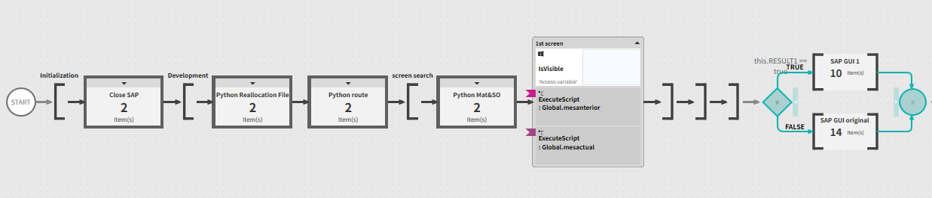

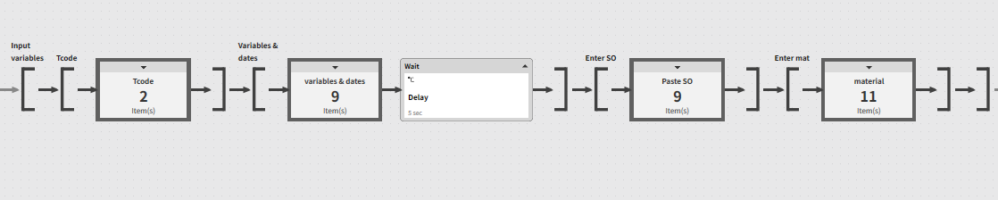
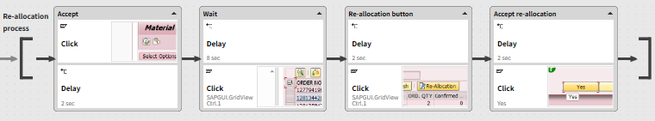

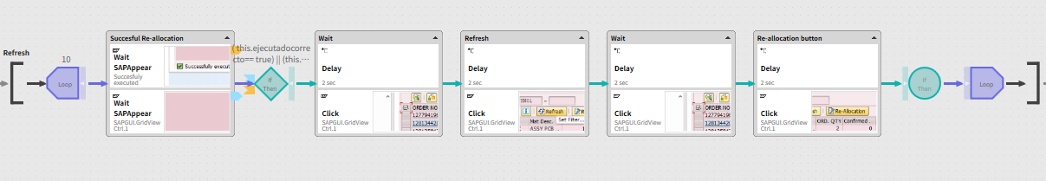

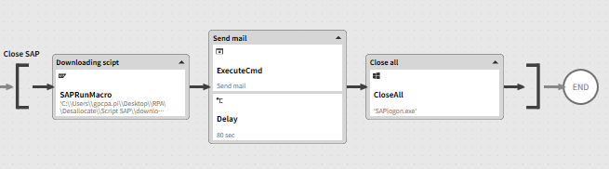

SAP GUI Re-Assignation Automation

🚀 SAP RPA Automation

– End-to-End Re-Allocation Process

Executive Summary

Enterprise-grade RPA solution that fully automates a critical SAP GUI re-allocation process, replacing a daily manual operation with a resilient, validated, and fault-tolerant automation.

The solution integrates Python business logic, SAP GUI scripting, validation checkpoints, retry mechanisms, and automated reporting, delivering ~50 business days saved per year and eliminating operational risk.

________________________________________
🎯 Business Problem

The SAP material and sales order re-allocation process was executed manually on a daily basis and suffered from:

• High operational dependency on SAP session state

• Repetitive execution with no automation support

• Risk of human error (incorrect SOs or materials)

• No built-in validation of successful execution

• No visibility into annual time loss or efficiency impact

This resulted in operational inefficiency, increased workload, and avoidable risk in a production SAP environment.

________________________________________
🧠 Solution Overview

A modular, resilient RPA architecture was designed to fully automate the process while separating business logic from SAP interaction and enforcing validation at every critical step.

The solution was built with enterprise stability as a core principle, ensuring safe execution even under SAP session instability or partial failures.

________________________________________
🖼 RPA Orchestration Breakdown

1. Initialization & Logic Preparation

• Forced closure of all existing SAP GUI sessions

• Python-based preprocessing for routing, file handling, and business rules

• Global variables used for synchronization across RPA and SAP layers

2. Data Input & SAP Navigation

• Controlled entry of Sales Orders, materials, dates, and organizational data

• Explicit waits and SAP GUI state validation before every interaction

• Defensive navigation to prevent SAP desynchronization

3. Re-Allocation Execution

• Precise material selection within SAP GridView

• Execution of re-allocation actions

• Handling of confirmation dialogs and system messages

4. Validation & Retry Logic

• Real-time SAP message validation (TRUE / FALSE)

• Conditional branching based on execution outcome

• Controlled retry loop with screen refresh and re-validation

(Designed to avoid partial allocations or inconsistent SAP states)

5. Post-Processing & Closure

• Automated results extraction via SAP macros

• Email notification with execution outcome

• Clean and safe shutdown of all SAP instances

________________________________________

📊 Results & Business Impact

Time Savings

• 1.5 hours saved per business day

• 374 hours saved per year

• Equivalent to ~50 business days annually

The automation completely eliminated a daily manual task and reduced operational risk to near zero.

________________________________________
🔍 Before vs After

Before

• Manual execution

• High human dependency

• Error-prone process

• No validation or retry mechanism

• No visibility into efficiency loss

After

• Fully automated end-to-end process

• Deterministic and validated execution

• Fault-tolerant retry logic

• Automated reporting and notifications

• Measurable, repeatable business impact
________________________________________
🧩 Key Features

• End-to-end SAP GUI automation

• Python-driven business logic and preprocessing

• Real-time SAP validation checkpoints

• Error handling with controlled retry loops

• Automated reporting and notifications

• Enterprise-safe system shutdown
________________________________________
🛠 Tech Stack

• SAP GUI Scripting (Enterprise SAP environment)

• Python (Business logic, preprocessing, validation)

• RPA Orchestration Platform

• SAP Macros (Results extraction)

• Email automation (SMTP)
________________________________________
🧠 Challenges & Design Decisions
• SAP session instability: addressed through forced session cleanup and validation checkpoints

• Timing and synchronization issues: mitigated with explicit waits and state verification

• Partial execution risk: eliminated through message-based validation and retry logic

• Infinite loop prevention: controlled retry limits and refresh logic
________________________________________
👤 My Role

• Designed the end-to-end RPA architecture

• Defined validation and retry strategy

• Integrated Python business logic with SAP GUI automation

• Implemented fault-tolerant execution mechanisms

• Ensured enterprise-grade stability and safe shutdown
________________________________________
🚀 Why This Project Matters

This project demonstrates the ability to:

• Design production-grade RPA solutions, not just task automation

• Architect resilient workflows for unstable enterprise systems

• Integrate multiple technologies into a single coherent solution

• Deliver measurable, high-impact business value

